Waitha quria alquranu faistamiAAoo lahu waansitoo laAAallakum turhamoona
7:204 When the Qur'an is read, listen to it with attention, and hold your peace: that ye may receive Mercy.

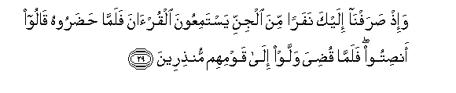
l-Ahqaf (The Curved Sandhills) [46:29]

[top] [next match]
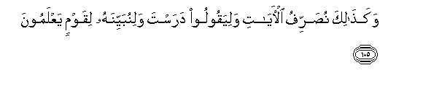
Al-An'am (The Cattle) [6:127]
[top] [next match]

Al-An'am (The Cattle) [6:156] [RECITE]
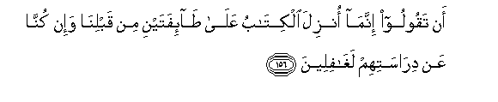Al-An'am (The Cattle) [6:156] 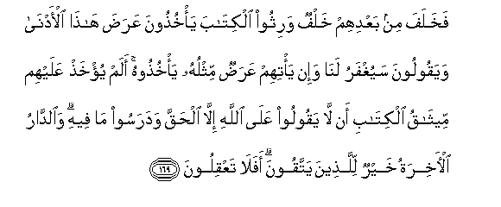Al-A'raf (The Heights) [7:169]

NN_UA037_Firdaws

